UCG Copyright Guidelines

Please follow these guidelines as you plan and present your upcoming events such as Women’s Weekends, virtual meetings, and other opportunities hosted for women.

- Do not record or archive any copyrighted material without permission that might be used in private virtual meetings, Women’s Weekends, seminars, Sabbath services, or other presentations. This includes songs, photos, poems, articles, and graphics. Even though they may be used elsewhere on the Web doesn’t mean they can be used freely. Never assume it’s in the public domain or anonymous. Do diligent research for authenticity. Acknowledging the source of the copyrighted material does not substitute for obtaining permission.

- There are a number of royalty-free photo and image websites that have a large selection. These include unsplash.com and commons.wikimedia.org. Both of these sites require giving the copyright holder’s name and your photo source. For example, neom-unsplash for this sample image at https://unsplash.com/photos/a-couple-of-people-are-swimming-in-a-cave-ijxWA9RHabI

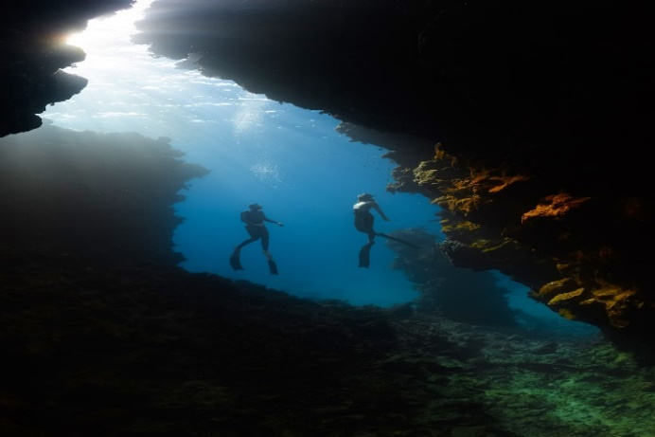 | Photo by NEOM on Unsplash  Home to kaleidoscopic-colored coral reefs and an abundance of diverse marine life | Islands of NEOM- NEOM, Saudi Arabia – Download this photo by NEOM on Unsplash  unsplash.com

- For printed brochures and graphics used at a Women’s Weekend, make sure what is used is royalty-free or has copyright permission—especially photos used in promotional brochures.

- If quoting copyrighted material, make sure to quote only a small portion of the author’s work, not an entire piece, and that due credit is given. It is best to keep quotes short enough to support the point and no more. Some older quotes may be in public domain.

- When quoting a source, the format should be in this order: author, article title, publication name, date of publication. UCG writers follow Chicago Manual of Style for quote style and other style issues: https://www.scribbr.com/chicago-style/author-date/

Please contact MMS if you have additional questions or concerns.

